Reception: Please remember these activities are a guide you do not have to stick to the days, if you cannot fit it all in choose the activities you can manage. As long as you and your child are spending some quality time learning. Please phone or video call on the ‘hangouts’ app between 9am-3pm Monday to Friday for any support or questions and come online to our group ‘check ins’. If we miss your call we will get back to you. Ms Turner is also available on hangouts to support too.
 | Phonics | Literacy | Maths | Physical Development , Outdoor activities, Extension activity
Monday  30.1.2020 | Introduce the alternative sound ‘ph’  ‘take a photo’ trophy, alphabet, elephant, nephew,  Say the sound tell your child it sounds like ‘f’. See sound card on tapestry and Google classroom | Focus story - Beauty and the Beast https://www.twinkl.co.uk/resource/t-t-11368-beauty-and-the-beast-powerpoint or your own Beauty and the Beast Books.  Draw a picture of Beauty in your book.  Describe Beauty. Write a sentence or more than one sentence using your sounds, finger spaces and a full stop. | Can you count the teddies/toys/vehicles in your house, record how many you have? Can you say what would be one more or less.If you want you could write down what you found out. | 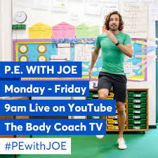  Joe Wicks frees PE sessions 9-9.30 am for free. https://www.youtube.com/watch?v=qGKGNzNbWjU  Cosmic Kids (YouTube) have meditation and kids Yoga sessions – free videos https://www.youtube.com/watch?v=LhYtcadR9nw  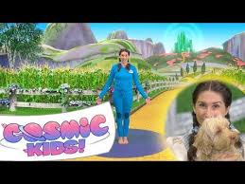
Tuesday  31.3.2020 |     Free on YouTube Set 2 and Set 3 Speed Sounds videos type in ‘Ruth Miskin videos’ https://www.youtube.com/watch?v=rI3-8SraW4A  https://www.youtube.com/watch?v=UpIqCdXRE-s | Draw a picture of the Beast .Describe the beast. Write a sentence using your sounds, finger spaces and a full stop. | Can you chalk/paint with water and a brush outside on a patio or wall/crayon numbers up to 20
Wednesday  1.4.2020 |  | Could you act out the story as a play with your family. Get Mum and Dad involved and your brothers and sisters dress up and make props, make your own masks. Take photos /Video it either post it on tapestry or Google classroo  Remember you might want to do this over a few days take as much time as you would like if you have free time at the weekend please feel free to do some of the activities then if you do not complete all of them do not worry pick the ones that you can manage. | Could you double a number? Add the same number to itself start with doubling numbers up to 5 and extend to 10? Eg. Double 1 is 1+1=2, double 2 is 2+2=4
Thursday  2.4.2020 |  |  | Can you identify a cube, cuboid, cylinder and sphere around house or in the food cupboard? Upload photos to tapestry. What did you find? | Outside – Look for signs of spring in your garden upload photos onto tapestry and Google classroom
Friday  3.4.2020 |  |  | Can you find some 1p coins around the house? Set up a shop and use your toys, make price labels for them and then pay for them using your pennies. Upload your photos onto Tapestry or Google Classroom | Extension activity- Writing – Write the story of Beauty and the Beast with a clear beginning, middle and end.

